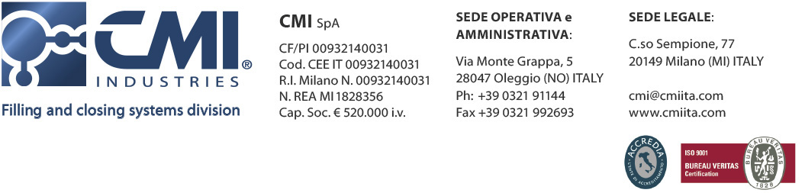

**CMI Industries** was founded in 1982, with the production of bottling machines for the domestic market.

Since the early years CMI Industries shows its propensity for constant growth and improvement and between 1988 and 1992 the company develops new stainless steel machines, implementing the production and expanding market areas of expertise.

In 1989, thanks to a **well-structured sales network**, started the first sales abroad, in northern Europe and the *Maghreb*, anticipating the **international aspiration** that now characterizes the company.

In 1999 establishes a **highly qualified internal Research and Development department** that deals with diversification of machinery and develops **new technologies** to anticipate needs and trends in the various operating segments.

In 2002 the development becomes operational: the production area is adjusted according to the new requirements and the **new plant** is born, three times larger than the former one, with an area of ​​almost 9,000 square meters.

In response to the growing demand coming from the food sector, the company acquires **KOHEM**, a leading brand in the machinery industry of **food, beverage & dairy**.

In 2012, the year of the 30th anniversary, the company creates the **INNOVA HT** division that designs and implements solutions for **coating and lamination**, acquiring increasingly specific and enriching skills to their own **knowhow**.

Today CMI Industries is a group with a **versatile and flexible organization and structure** and with the **design, production, assembly and testing inhouse departments**.

Thanks to the company philosophy, dedicated to constant research and innovation, in 2014 CMI Industries marked a **25% revenue growth** with clients all over the world and constantly growing and an **85% export rate**.

CMI Industries holds **4 patented systems**, with the aim to facilitate the work of their customers and increase machines productivity, reducing production time and costs.



**FRANCO COMOLI, President of CMI Industries**, has a secret ingredient that explains the success of his company and its products:

"Here we give a soul to the machines, this is the secret!" And adds, "Each machine has its own history, her character let’s say, and each creation is for us a child who becomes part of the family"

CMI Industries from over thirty years offers **packaging solutions**, continuously investing in research and technological development, looking at the future with curiosity and enthusiasm, always being able to meet customer needs, remaining a reference point with **'avant-garde, reliable and safe machines**.

Talking about the history of his company, Franco Comoli recounts:

"In the 80s and 90s the market was less demanding than today: to satisfy customers we just needed to be there.

And we were there.

In the 2000s we must be organized, reliable, competent.

And so we are.

In future years? The world has changed, is still changing and it will continue changing.

And we'll be there! "

**CMI Industries**

Via Montegrappa 5

28047 Oleggio (NO – Italy

Ph: +39 0321 91144

Fax: +39 0321 992693

28047

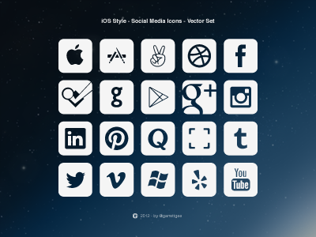

**CMI Industries**

Via Montegrappa 5

28047 Oleggio (NO – Italy

Ph: +39 0321 91144

Fax: +39 0321 992693

28047

