Active since 1994, GEMINAS is a vocational training centre registered and accredited by Regione Lombardia for
- vocational and continuous training
- counselling and work placement services

We have been active for more than 15 years providing adult and vocational training, counselling and research in major sectors and areas such as ICT, COMMERCE, TOURISM, HEALTH SERVICES, ect, with the mission of opening new jobs in tune with labour market changes and equal opportunity issues.
At international level GEMINAS has been developing projects for more than 20 years at regional/national /EU level in areas such as HRs (innovative Human Resources), ICT, Cultural Heritage, Tourism through

- field-research (i.e. studies re technology costs and logistics for overall efficiency in pilot projects in the wood -base chain for sustainable management of forestry resources )
- diffusion actions at transnational level – editing in more than 10 foreign languages (English – Chinese –Spanish –French –Portuguese – German – Swedish – Russian – Turkish – Arabic – Rumanian – Bulgarian )
- organisation of meetings and seminars; support and coaching to project participants (technicians, operators, personnel employed by public environmental agencies, beside local, regional and national institutional stakeholders and trade and industrial associations)
- developing operative networks with stakeholders and relevant beneficiaries (companies, industrial associations, high schools, research and university centres)
- selection and training of operators of the whole productive chain

GEMINAS has two training centres located in Milan and Sondrio, in the north of Regione Lombardia. Our staff can guarantee the most effective implementation of direction, coordination, secretarial and administration activities for all kinds of projects.
GEMINAS is the main promoter of WIS – WORLD ITALIA STAGE - a EU-based network project aiming at promoting job opportunities at international level.

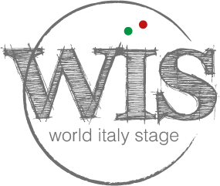
MOBILITA’ INTERNAZIONALE
ENTER THE FUTURE
步入未来

